Alexander Cleveland

1) a) 128x14

b) 28 locations will be wasted

c) 7 address lines

d) 14 data lines

e) 98

f) 00 and 7F

2) a) 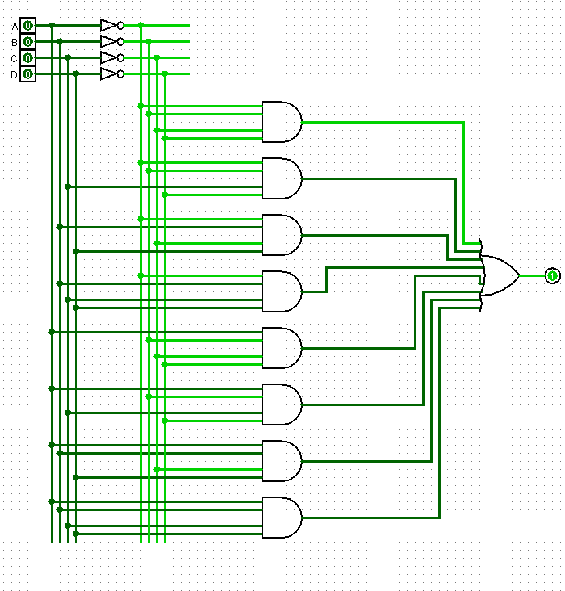

b) c)

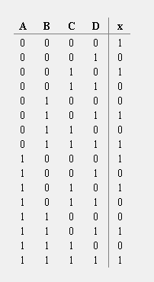 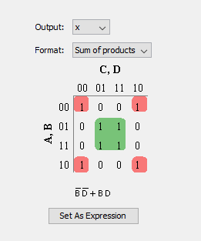

d)

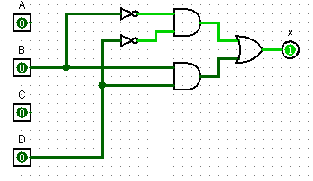

e)

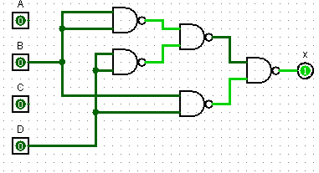

3) Design Work

|  |  |  |  |  |  |  |  |  |  |  |  |
| --- | --- | --- | --- | --- | --- | --- | --- | --- | --- | --- | --- |
| A | B | C | D | a | b | c | d | e | f | g | Hex in Rom |
| 0 | 0 | 0 | 0 | 1 | 1 | 1 | 1 | 1 | 1 | 0 | 7E |
| 0 | 0 | 0 | 1 | 0 | 1 | 1 | 0 | 0 | 0 | 0 | 30 |
| 0 | 0 | 1 | 0 | 1 | 1 | 0 | 1 | 1 | 0 | 1 | 6D |
| 0 | 0 | 1 | 1 | 1 | 1 | 1 | 1 | 0 | 0 | 1 | 79 |
| 0 | 1 | 0 | 0 | 0 | 1 | 1 | 0 | 0 | 1 | 1 | 33 |
| 0 | 1 | 0 | 1 | 1 | 0 | 1 | 1 | 0 | 1 | 1 | 5B |
| 0 | 1 | 1 | 0 | 1 | 0 | 1 | 1 | 1 | 1 | 1 | 5F |
| 0 | 1 | 1 | 1 | 1 | 1 | 1 | 0 | 0 | 0 | 0 | 70 |
| 1 | 0 | 0 | 0 | 1 | 1 | 1 | 1 | 1 | 1 | 1 | 7F |
| 1 | 0 | 0 | 1 | 1 | 1 | 1 | 0 | 0 | 1 | 1 | 73 |
| 1 | 0 | 1 | 0 | 1 | 1 | 1 | 0 | 1 | 1 | 1 | 77 |
| 1 | 0 | 1 | 1 | 0 | 0 | 1 | 1 | 1 | 1 | 1 | 1F |
| 1 | 1 | 0 | 0 | 1 | 0 | 0 | 1 | 1 | 1 | 0 | 4E |
| 1 | 1 | 0 | 1 | 0 | 1 | 1 | 1 | 1 | 0 | 1 | 3D |
| 1 | 1 | 1 | 0 | 1 | 0 | 0 | 1 | 1 | 1 | 1 | 4F |
| 1 | 1 | 1 | 1 | 1 | 0 | 0 | 0 | 1 | 1 | 1 | 47 |

3) Circuit

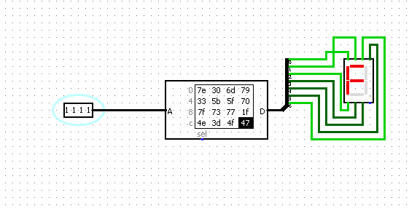

Contents of the Table File

v2.0 raw

7e 30 6d 79 33 5b 5f 70

7f 73 77 1f 4e 3d 4f 47